SAVEETHA SCHOOL OF ENGINEERING
CSA15- CLOUD COMPUTING AND BIG DATA ANALYTICS
LIST OF EXPERIMENT 2
2) Create a simple cloud software application for Flight Reservation System using any Cloud Service Provider to demonstrate SaaS.
SOL
AIM:
To design and implement a simple cloud-based Flight Ticket Reservation System using Zoho Creator and deploy it as a Software as a Service (SaaS) application, demonstrating relational database design via multi-table lookups, multi-user role simulation, and shared cloud database access through a web browser.
PROCEDURE:
- Sign In: Sign in to the Zoho Creator cloud platform using the registered student account credentials.
- Application Shell: Create a completely fresh standalone application by selecting the Create from Scratch option and name it SaaS Experiment 2 Flight Reservation.
- Form 1 (Passengers Table): Design the first data entry form named Passengers, adding a Name field labeled Passenger Name and an Email field labeled Email. Publish and save the form configuration.
- Form 2 (Flights Table): Design the second data entry form named Flights, adding a Single Line text field labeled Flight Number and two Drop Down menus labeled Source and Destination containing identical city routing options (Chennai, Mumbai, Delhi). Save the form.
- Form 3 (Reservations Relational Table): Create the third form named Reservations to act as the relational junction table connecting passengers to scheduled flights:
  - Drag a Lookup Field linking directly to the Passengers form, choosing Passenger Name as the active display value.
  - Drag a second Lookup Field linking directly to the Flights form, choosing Flight Number as the active display value.
  - Add a Number field labeled Seat Number to capture specific booking details.
- Report Generation: Generate standard list view reports for Passengers, Flights, and Reservations to enable real-time tracking, data filtering, and secure cloud search functionality.
- Deployment & SaaS Access: Click on the blue Access This Application button to compile and deploy the complete system live onto the Zoho cloud infrastructure.
- Functional Cloud Testing: Populate the live cloud application database by sequentially inserting 3 unique sample entries into the Passengers form, 3 entries into the Flights form, and executing cross-table relational links inside the Reservations form to simulate live tenant transactions.
SNAPSHOTS:
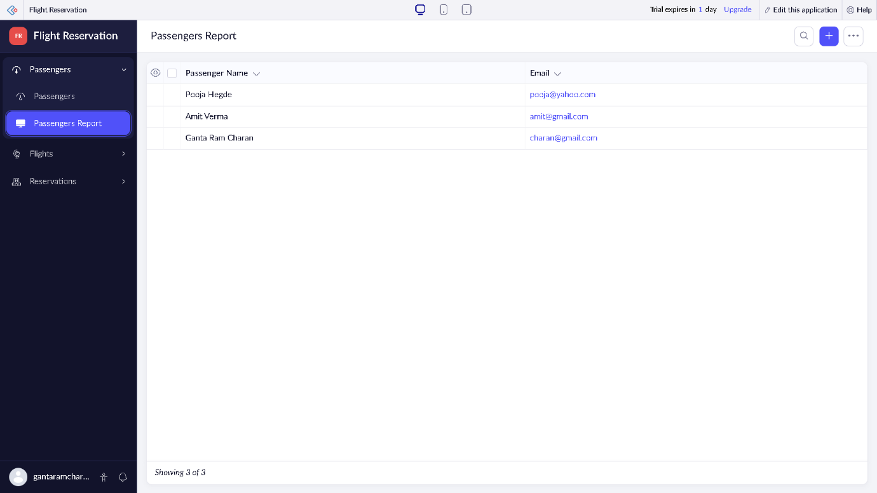

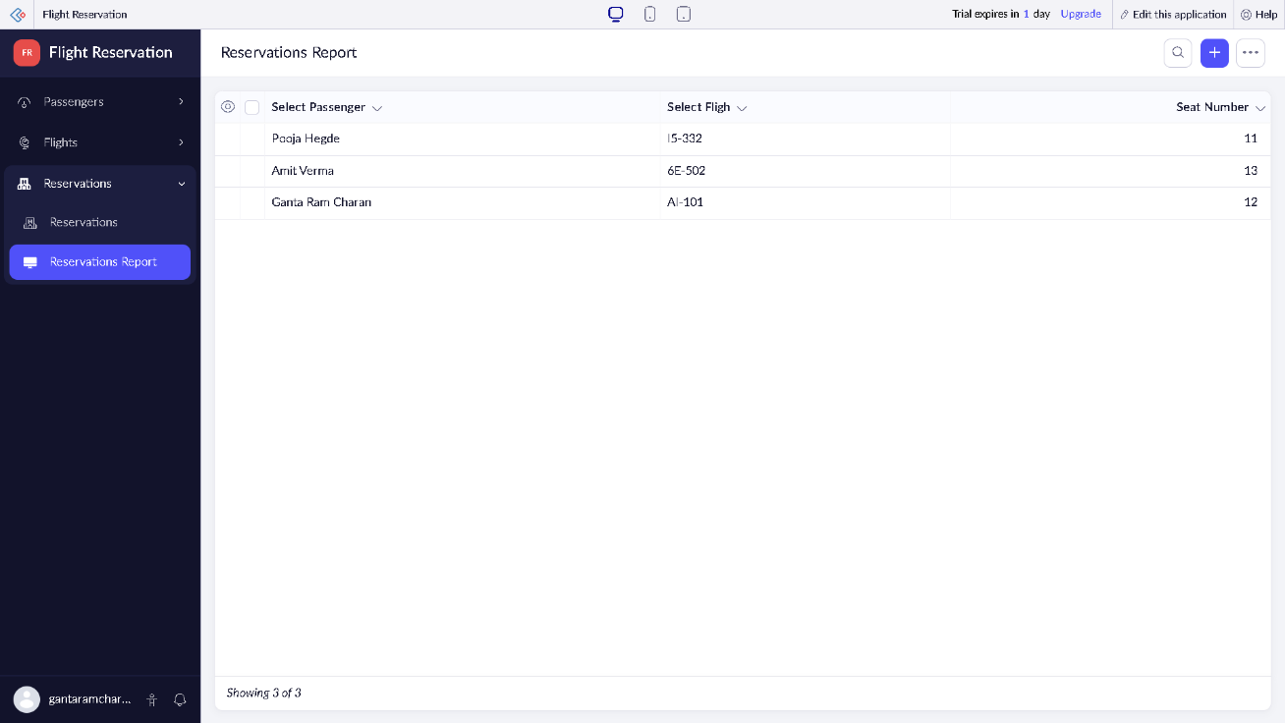
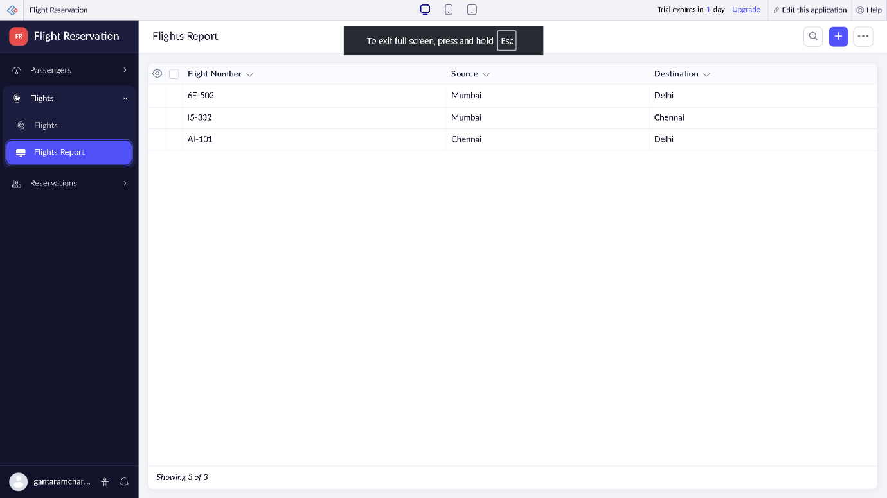
RESULT:
A relational cloud-based Flight Ticket Reservation System application was successfully developed, integrated, and deployed using the Zoho Creator SaaS platform. The entire system was securely managed and updated live through an internet web browser without requiring any local software installation, successfully validating multi-user SaaS relational architecture concepts.

